Język angielski (11)
Wild animals - zapoznanie z nazwami zwierząt
1. Posłuchaj i powtórz:
a zebra - zebra
a hippo - hipopotam
a giraffe - żyrafa
a lion - lew
a monkey - małpa
an elephant - słoń
a crocodile - krokodyl
a tiger - tygrys
https://www.youtube.com/watch?v=VOFl1Ioz1ss
https://www.youtube.com/watch?v=NNELmTbw9yM
2. Zabawa " Show me..." Pokaż mi... ". Prosimy dzieci o wskazanie wybranego zwierzęcia.
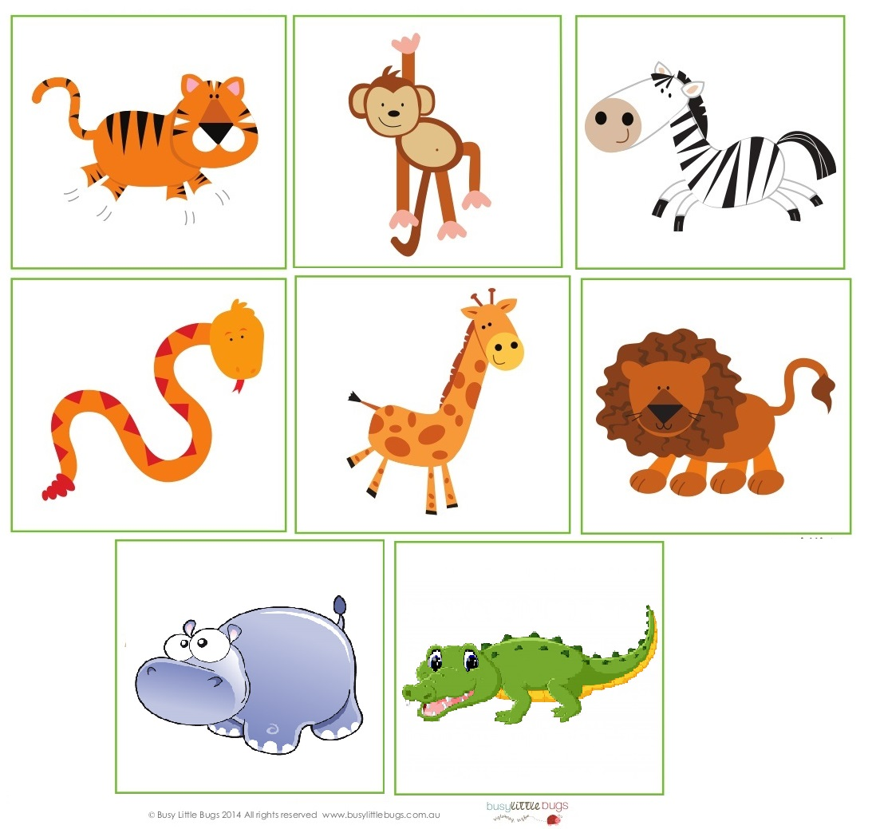

4. Piosenka "Walking in the jungle" - zabawa przy piosence
a frog- żaba
a monkey - małpa
a toucan - tukan
a tiger - tygrys
https://www.youtube.com/watch?v=GoSq-yZcJ-4
Let's take a walk in the jungle. (wybieramy się na spacer po dżungli)
Walking in the jungle. Walking in the jungle. (spacerujemy w dżungli)
We're not afraid. We're not afraid. (nie boimy się)
Walking in the jungle. Walking in the jungle.
We're not afraid. We're not afraid.
One step. Two steps. Three steps forward. (1,2,3 kroki do przodu)
One step. Two steps. Three steps back. (1,2,3 kroki do tyłu)
Stop. Listen. What's that? (Zatrzymujemy się. Słuchamy. Co to?)
It's a frog! (To żaba)
We're not afraid!
Let's stomp. (Tupiemy)
Stomping in the jungle. Stomping in the jungle.
We're not afraid. We're not afraid.
Stomping in the jungle. Stomping in the jungle.
We're not afraid. We're not afraid.
One step. Two steps. Three steps forward.
Stop. Listen. What's that?
It's a monkey! We're not afraid!
Let's jump. (Skaczemy obunóż)
Jumping in the jungle. Jumping in the jungle.
We're not afraid. We're not afraid.
Jumping in the jungle. Jumping in the jungle.
We're not afraid. We're not afraid.
One step. Two steps. Three steps forward.
One step. Two steps. Three steps back.
Stop. Listen. What's that?
It's a toucan!
We're not afraid!
Let's skip. (Podskakujemy z nogi na nogę)
Skipping in the jungle . Skipping in the jungle .
We're not afraid. We're not afraid.
Skipping in the jungle. Skipping in the jungle .
We're not afraid. We're not afraid.
One step. Two steps. Three steps forward.
One step. Two steps. Three steps back.
Stop. Listen. What's that?
It's a tiger!
RUN! (Uciekamy)
Zachęcam do wykonania opasek na głowę, aby naśladować wybrane zwierzęta. Aby zrobić opaskę należy wyciąć dwa paski z brystolu i skleić. Dzieci kolorują obrazek , wycinają go i przykleją do opaski.
